**nslookup**

1. [www.aiit.or.kr](http://www.aiit.or.kr) – 58.229.6.225
2. (Trinity College Dublin) tcd.ie

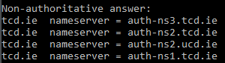

1. nslookup mail.yahoo.com auth-ns3.tcd.ie

Address: 193.1.193.161

**ipconfig**

1. ipconfig /displaydns

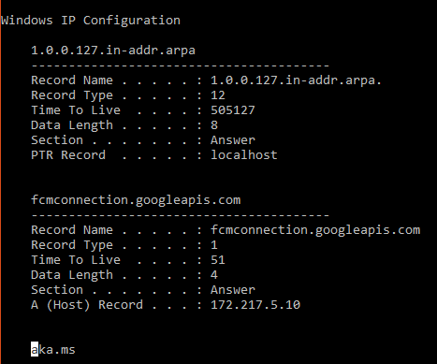

**Tracing DNS with Wireshark**

**www.ietf.org**

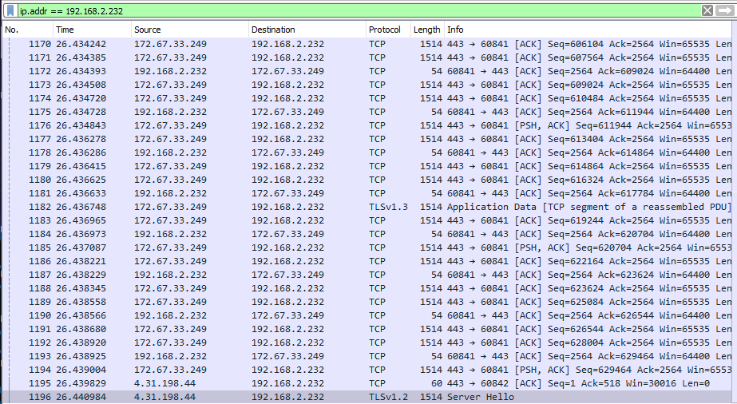

**nslookup**

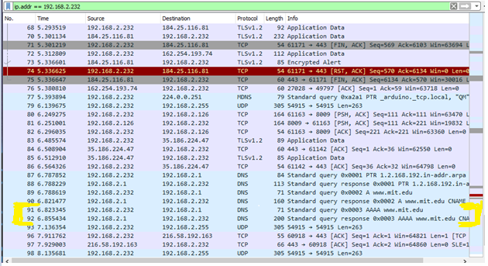

**nslookup -type=NS mit.edu**

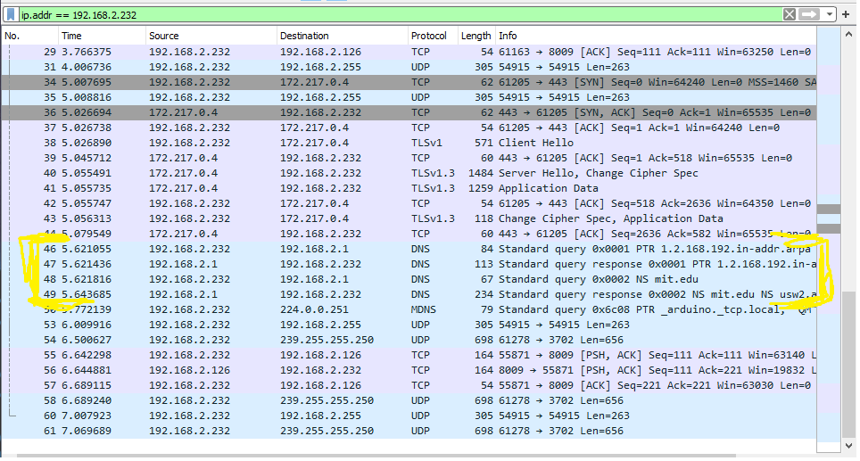

**nslookup** [**www.google.com**](http://www.google.com) **asia1.akam.net (aiit.or.kr doesn’t seem to exist anymore)**

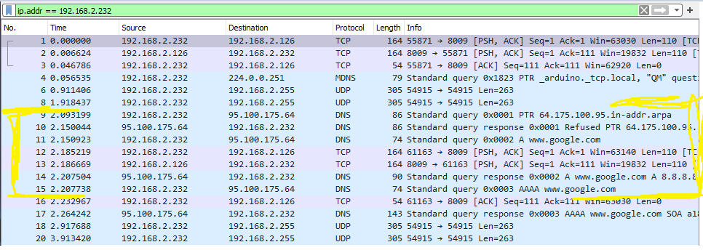

**Python DNS**

